Evaluation: Random Forest
Accuracy: 0.9039190897597977
Precision: 0.9354524485021949
Recall: 0.9039190897597977
F1 Score: 0.913447062381904
Jaccard Index: 0.8583831265892004
Matthews CorrCoef: 0.8819373478203993
Cohen’s Kappa: 0.8772729592617923
Specificity: 0.9855431126116487
AUC: 1.0
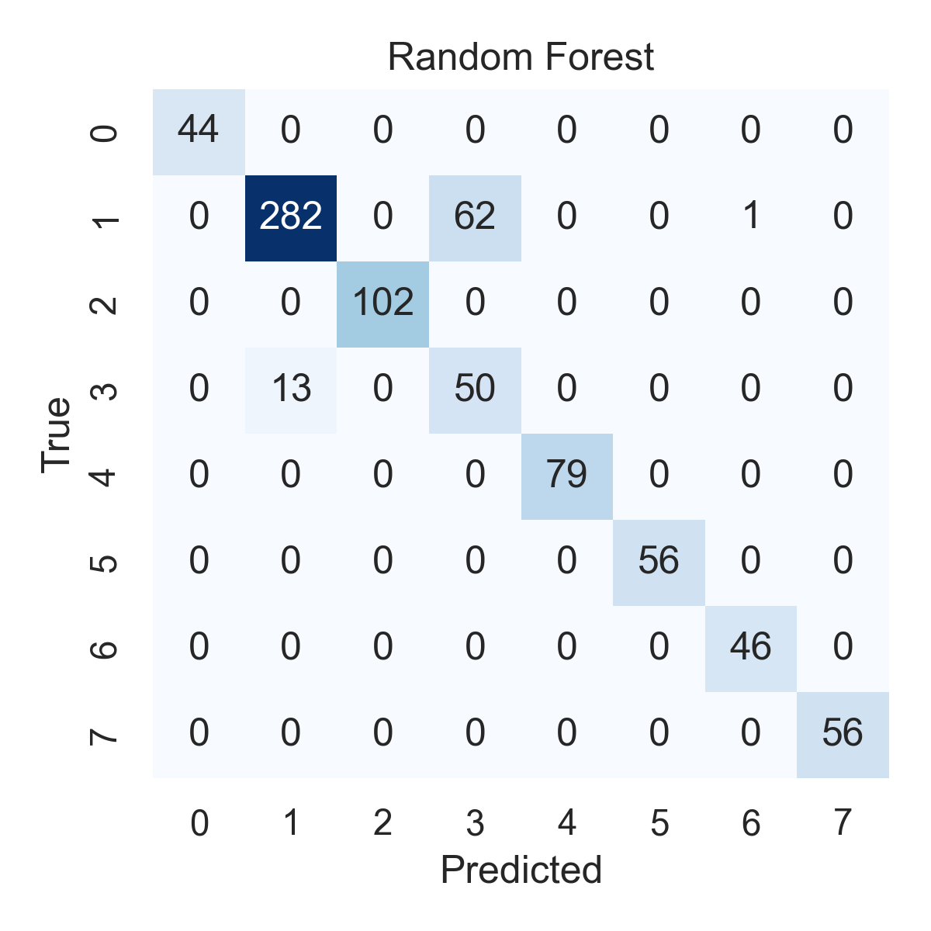

Combined ROC Curves
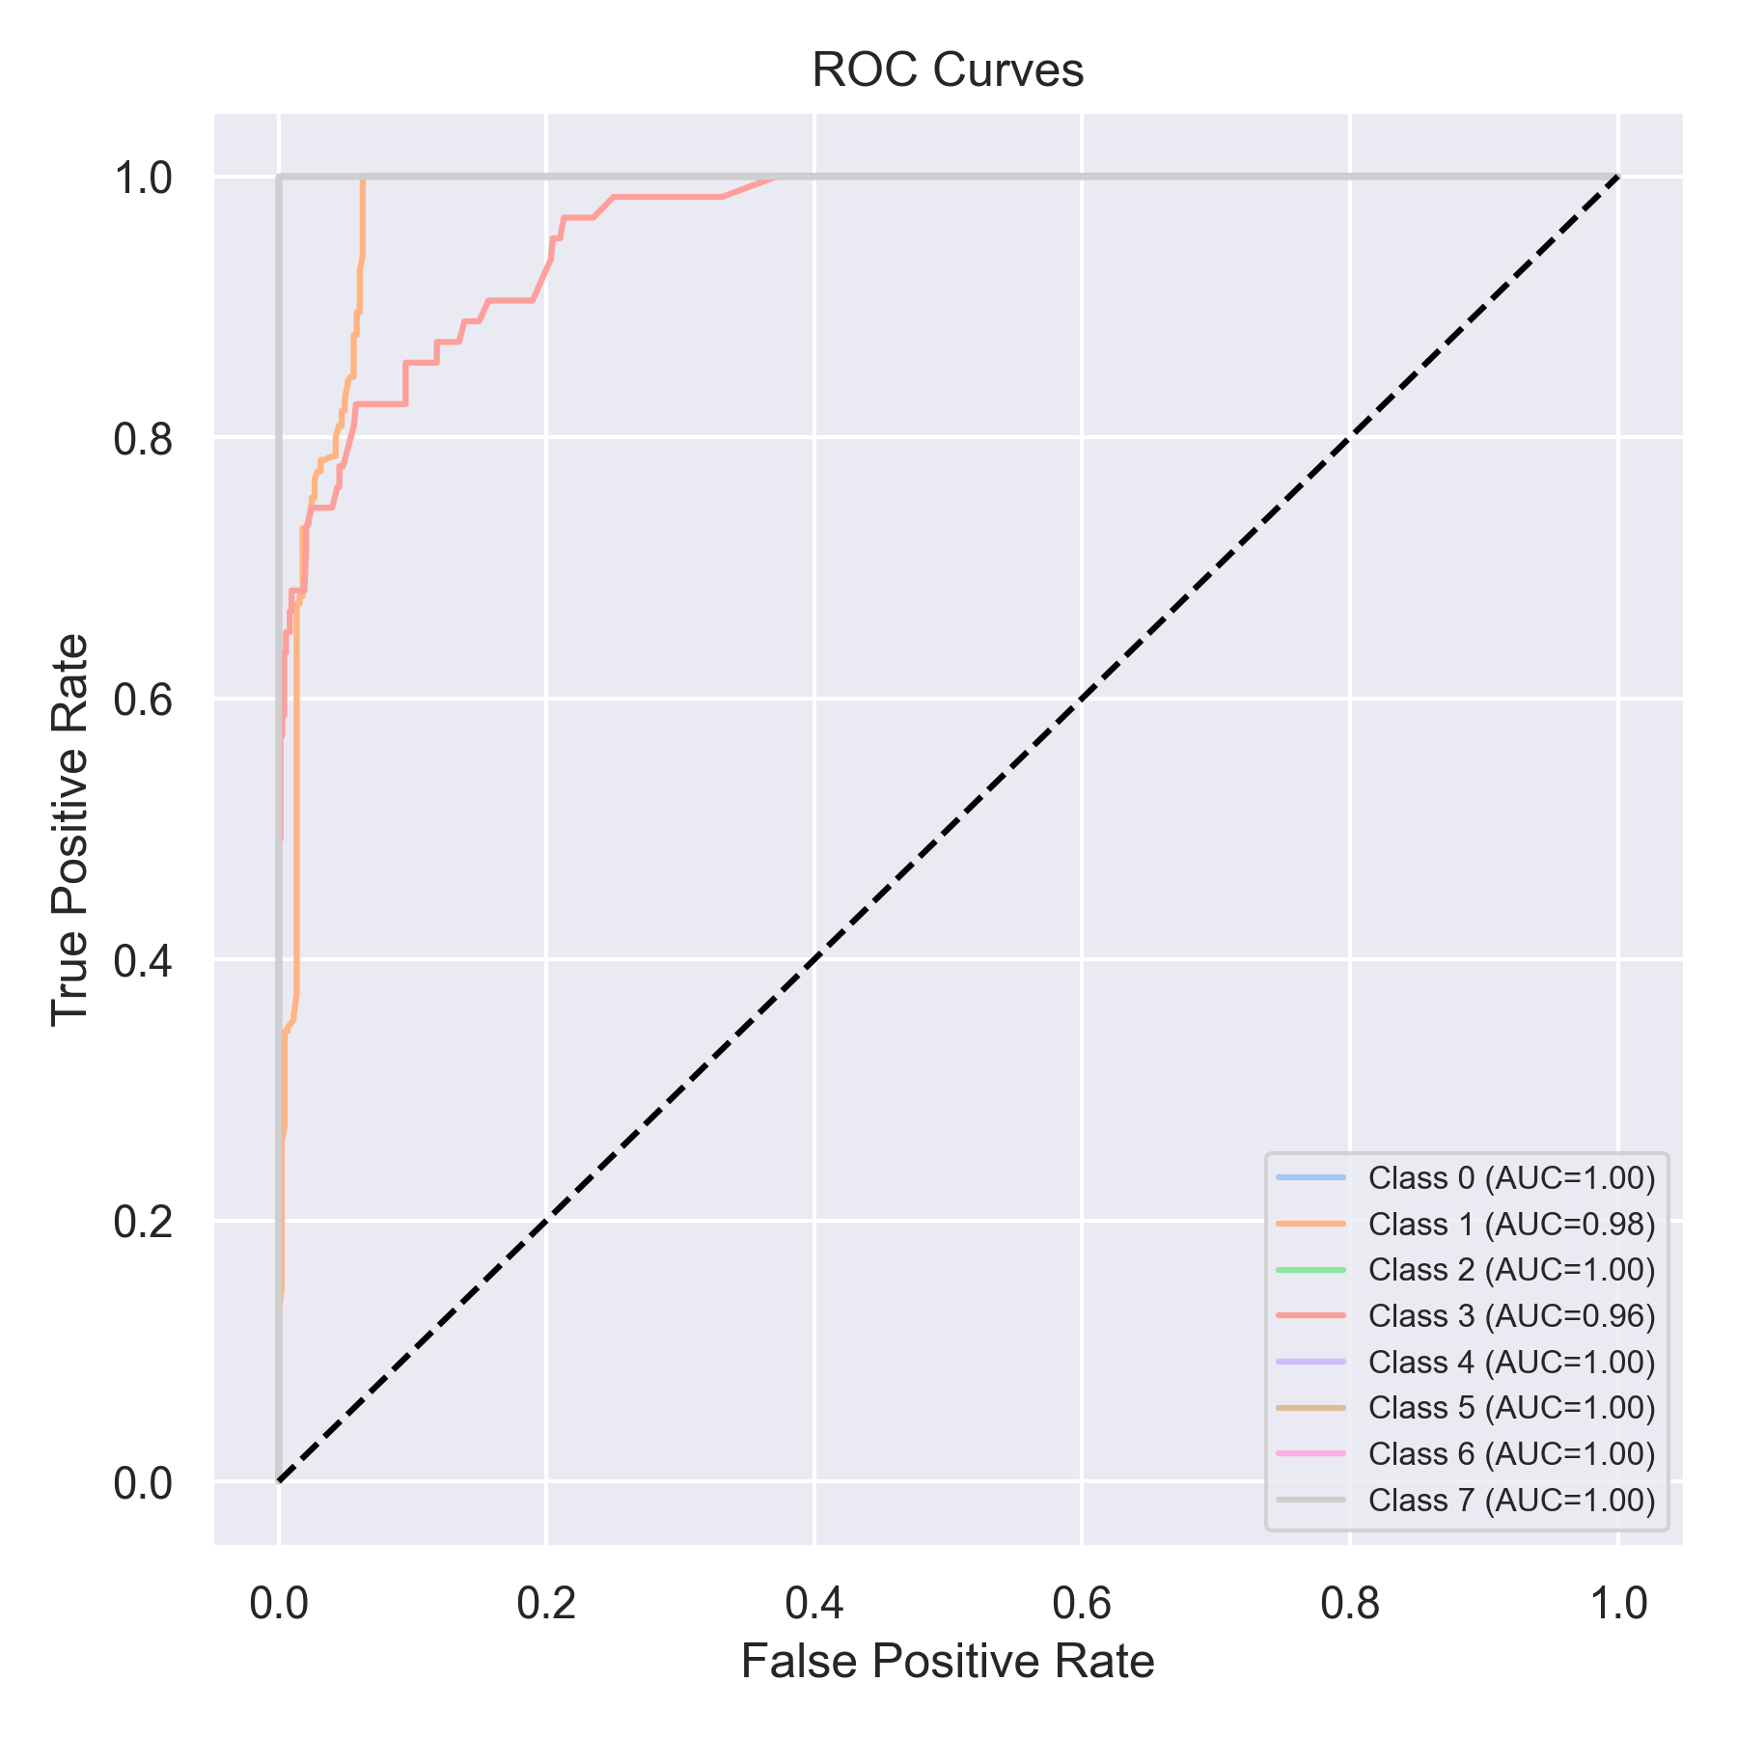

Evaluation: K-Nearest Neighbors
Accuracy: 0.6915297092288243
Precision: 0.7539368872044587
Recall: 0.6915297092288243
F1 Score: 0.6876226666114478
Jaccard Index: 0.5276921929922154
Matthews CorrCoef: 0.6464442492768361
Cohen’s Kappa: 0.6283166753326785
Specificity: 0.9559963599830554
AUC: 0.9919582118561711
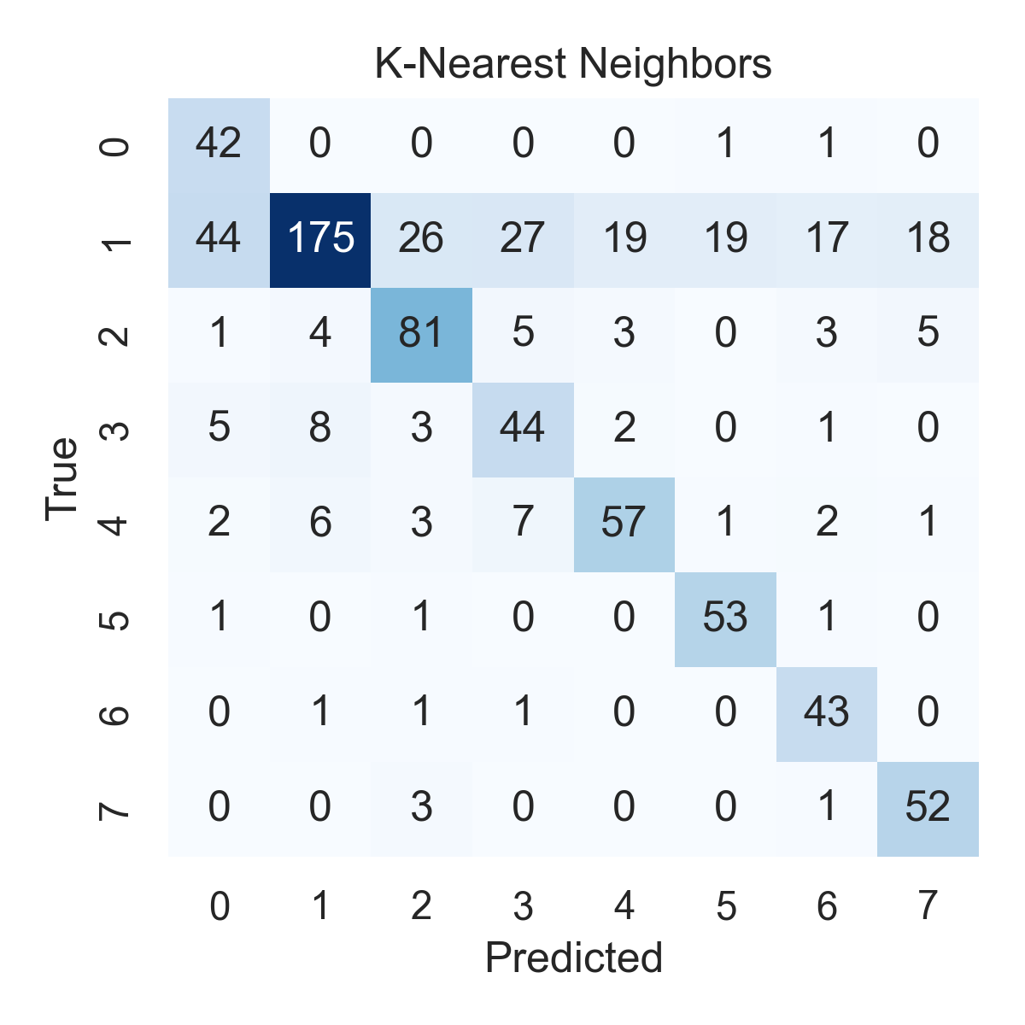

Combined ROC Curves
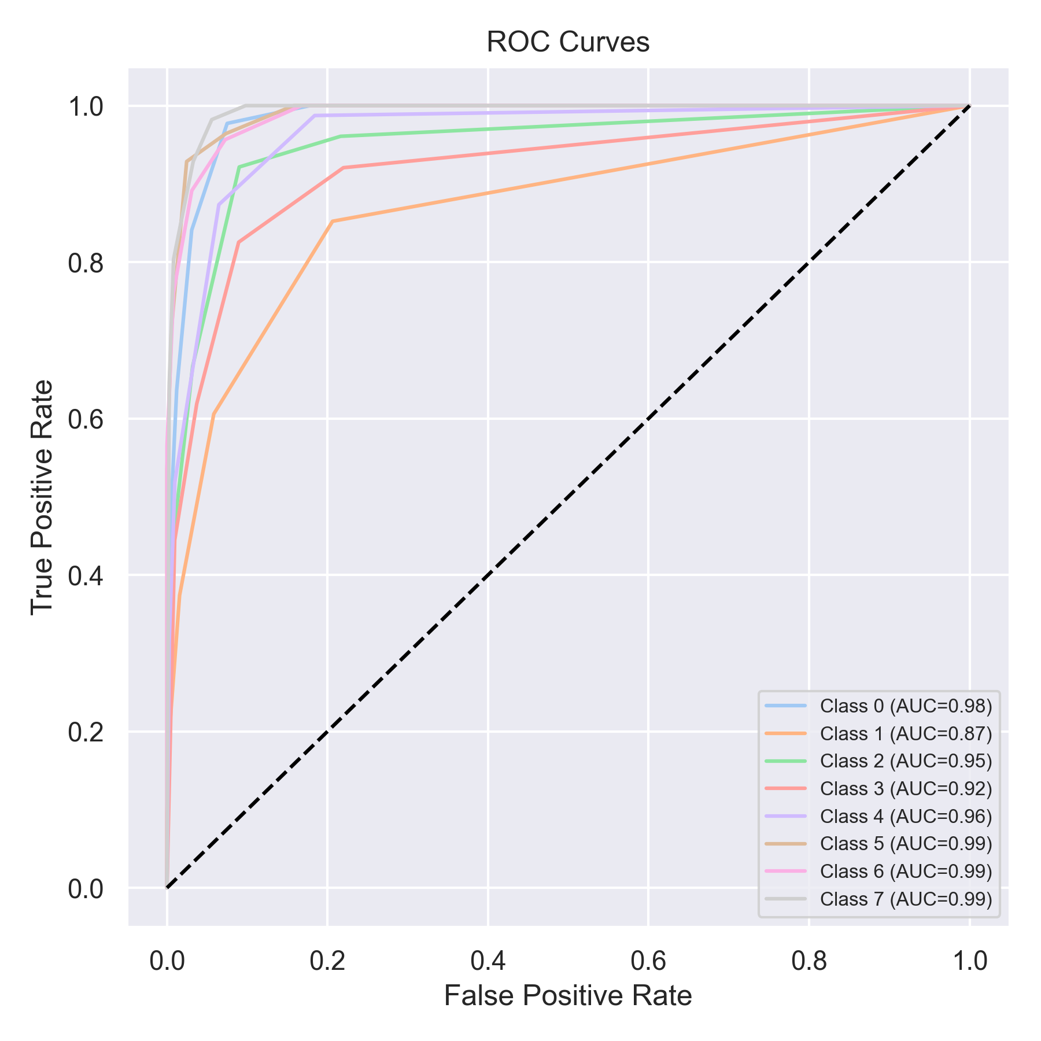

Evaluation: Decision Tree
Accuracy: 0.7408343868520859
Precision: 0.8749341550779605
Recall: 0.7408343868520859
F1 Score: 0.774975684961858
Jaccard Index: 0.6915282025592486
Matthews CorrCoef: 0.7205343994134544
Cohen’s Kappa: 0.6874807271269543
Specificity: 0.9619781143744148
AUC: 1.0
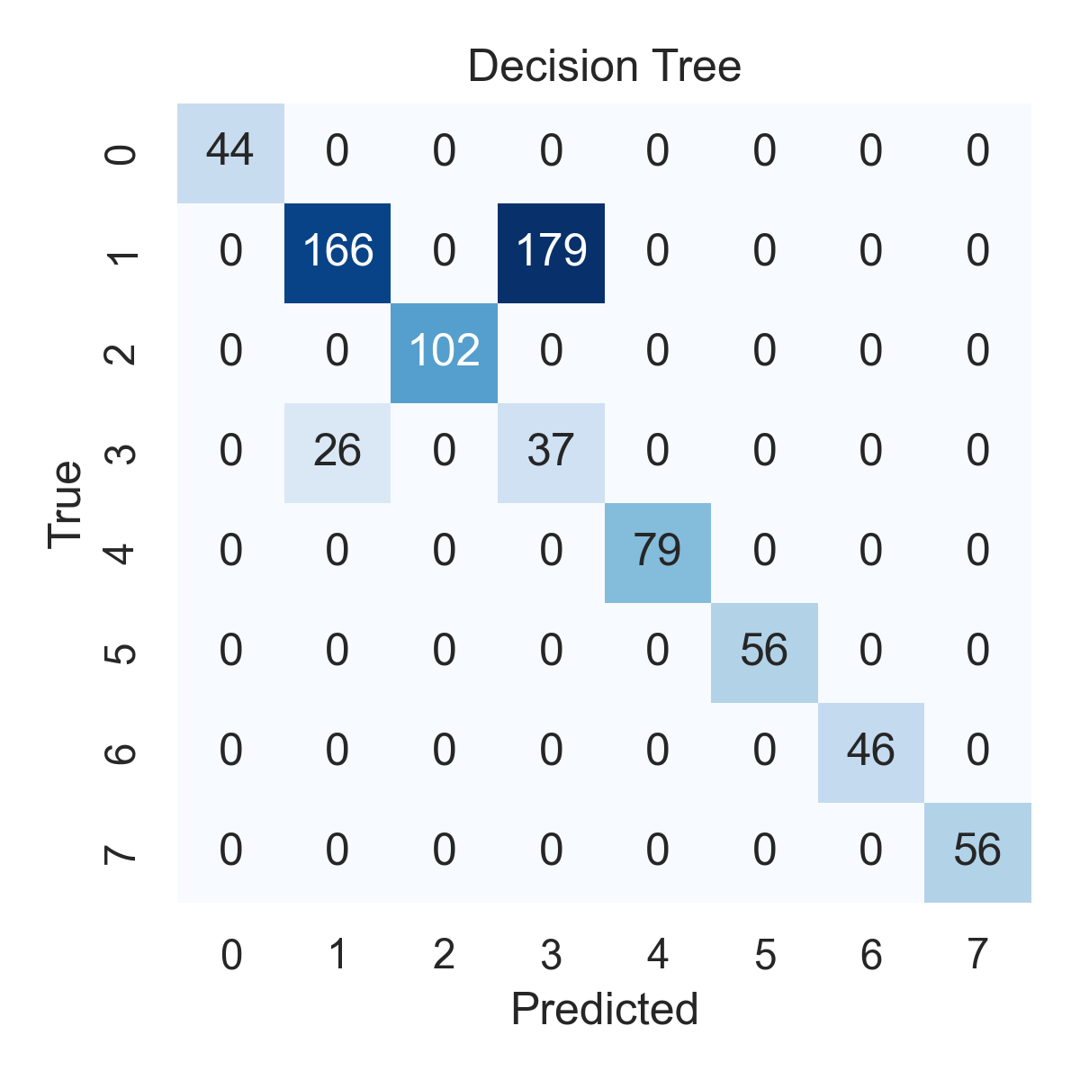

Combined ROC Curves
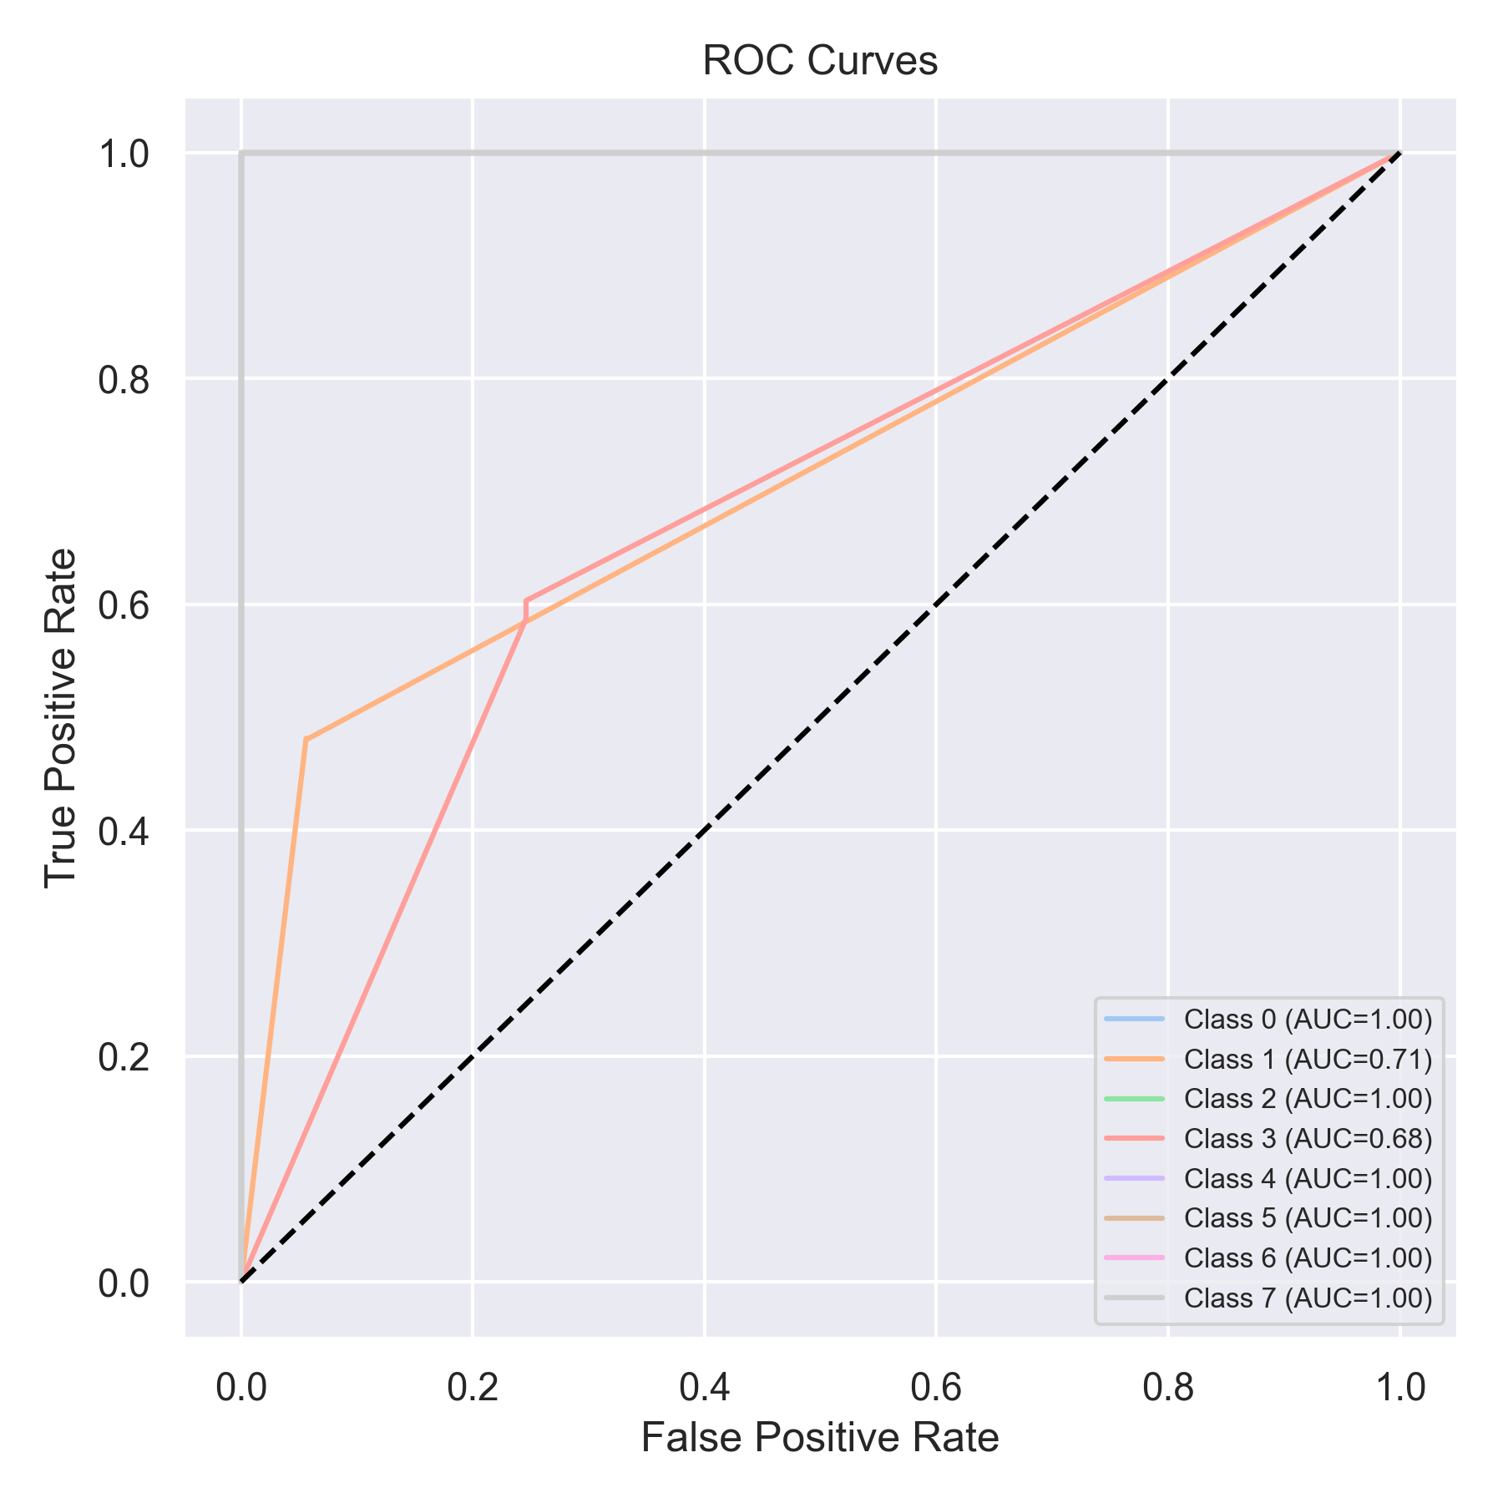

Evaluation: Extra Trees
Accuracy: 0.9734513274336283
Precision: 0.9736040473445586
Recall: 0.9734513274336283
F1 Score: 0.9735018279934716
Jaccard Index: 0.9509230554349926
Matthews CorrCoef: 0.9651606545936218
Cohen’s Kappa: 0.9651468736886277
Specificity: 0.9954254242626945
AUC: 1.0
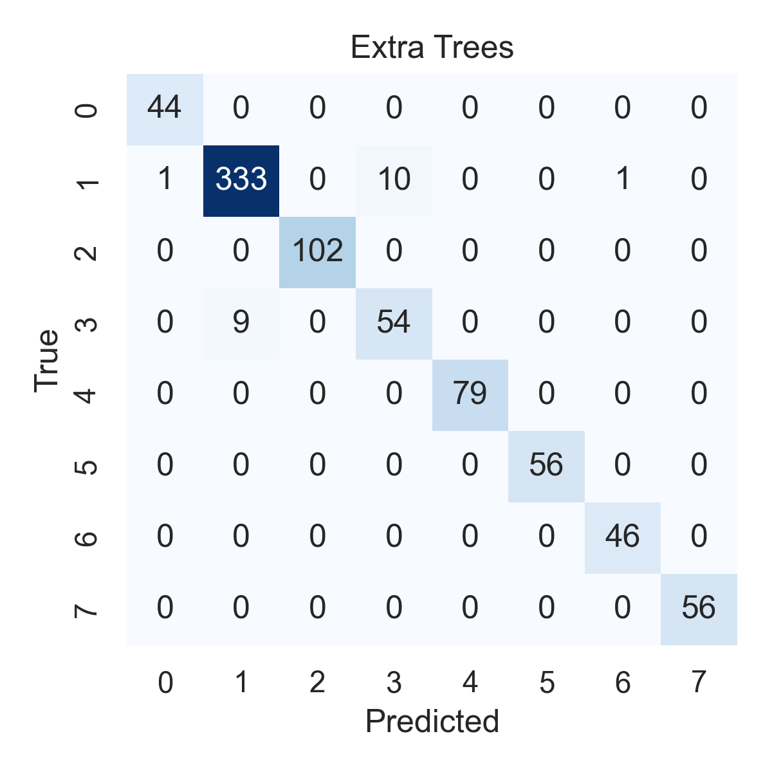

Combined ROC Curves
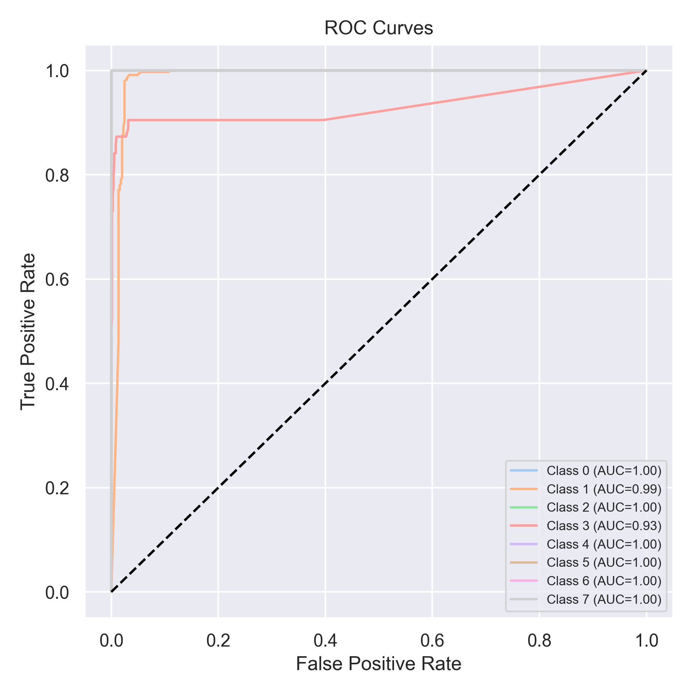

Evaluation: Bagging Classifier
Accuracy: 0.7408343868520859
Precision: 0.8756602148676041
Recall: 0.7408343868520859
F1 Score: 0.7742176704704768
Jaccard Index: 0.6899540102056719
Matthews CorrCoef: 0.7215066495527519
Cohen’s Kappa: 0.6877966225699813
Specificity: 0.9620769610814771
AUC: 1.0
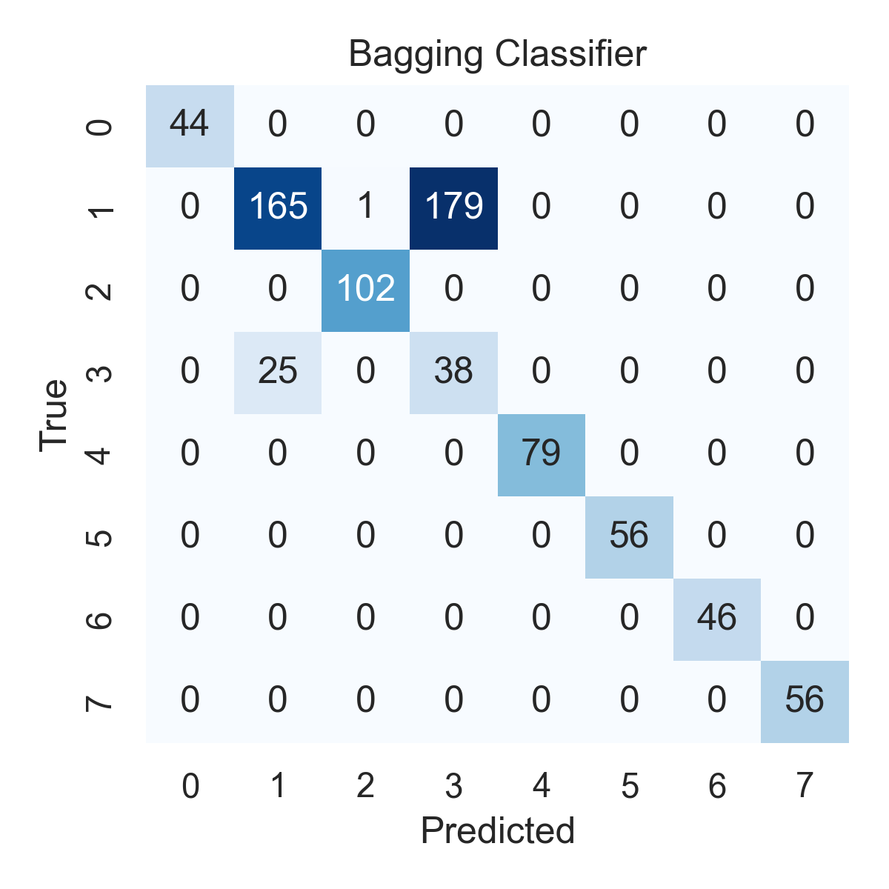

Combined ROC Curves
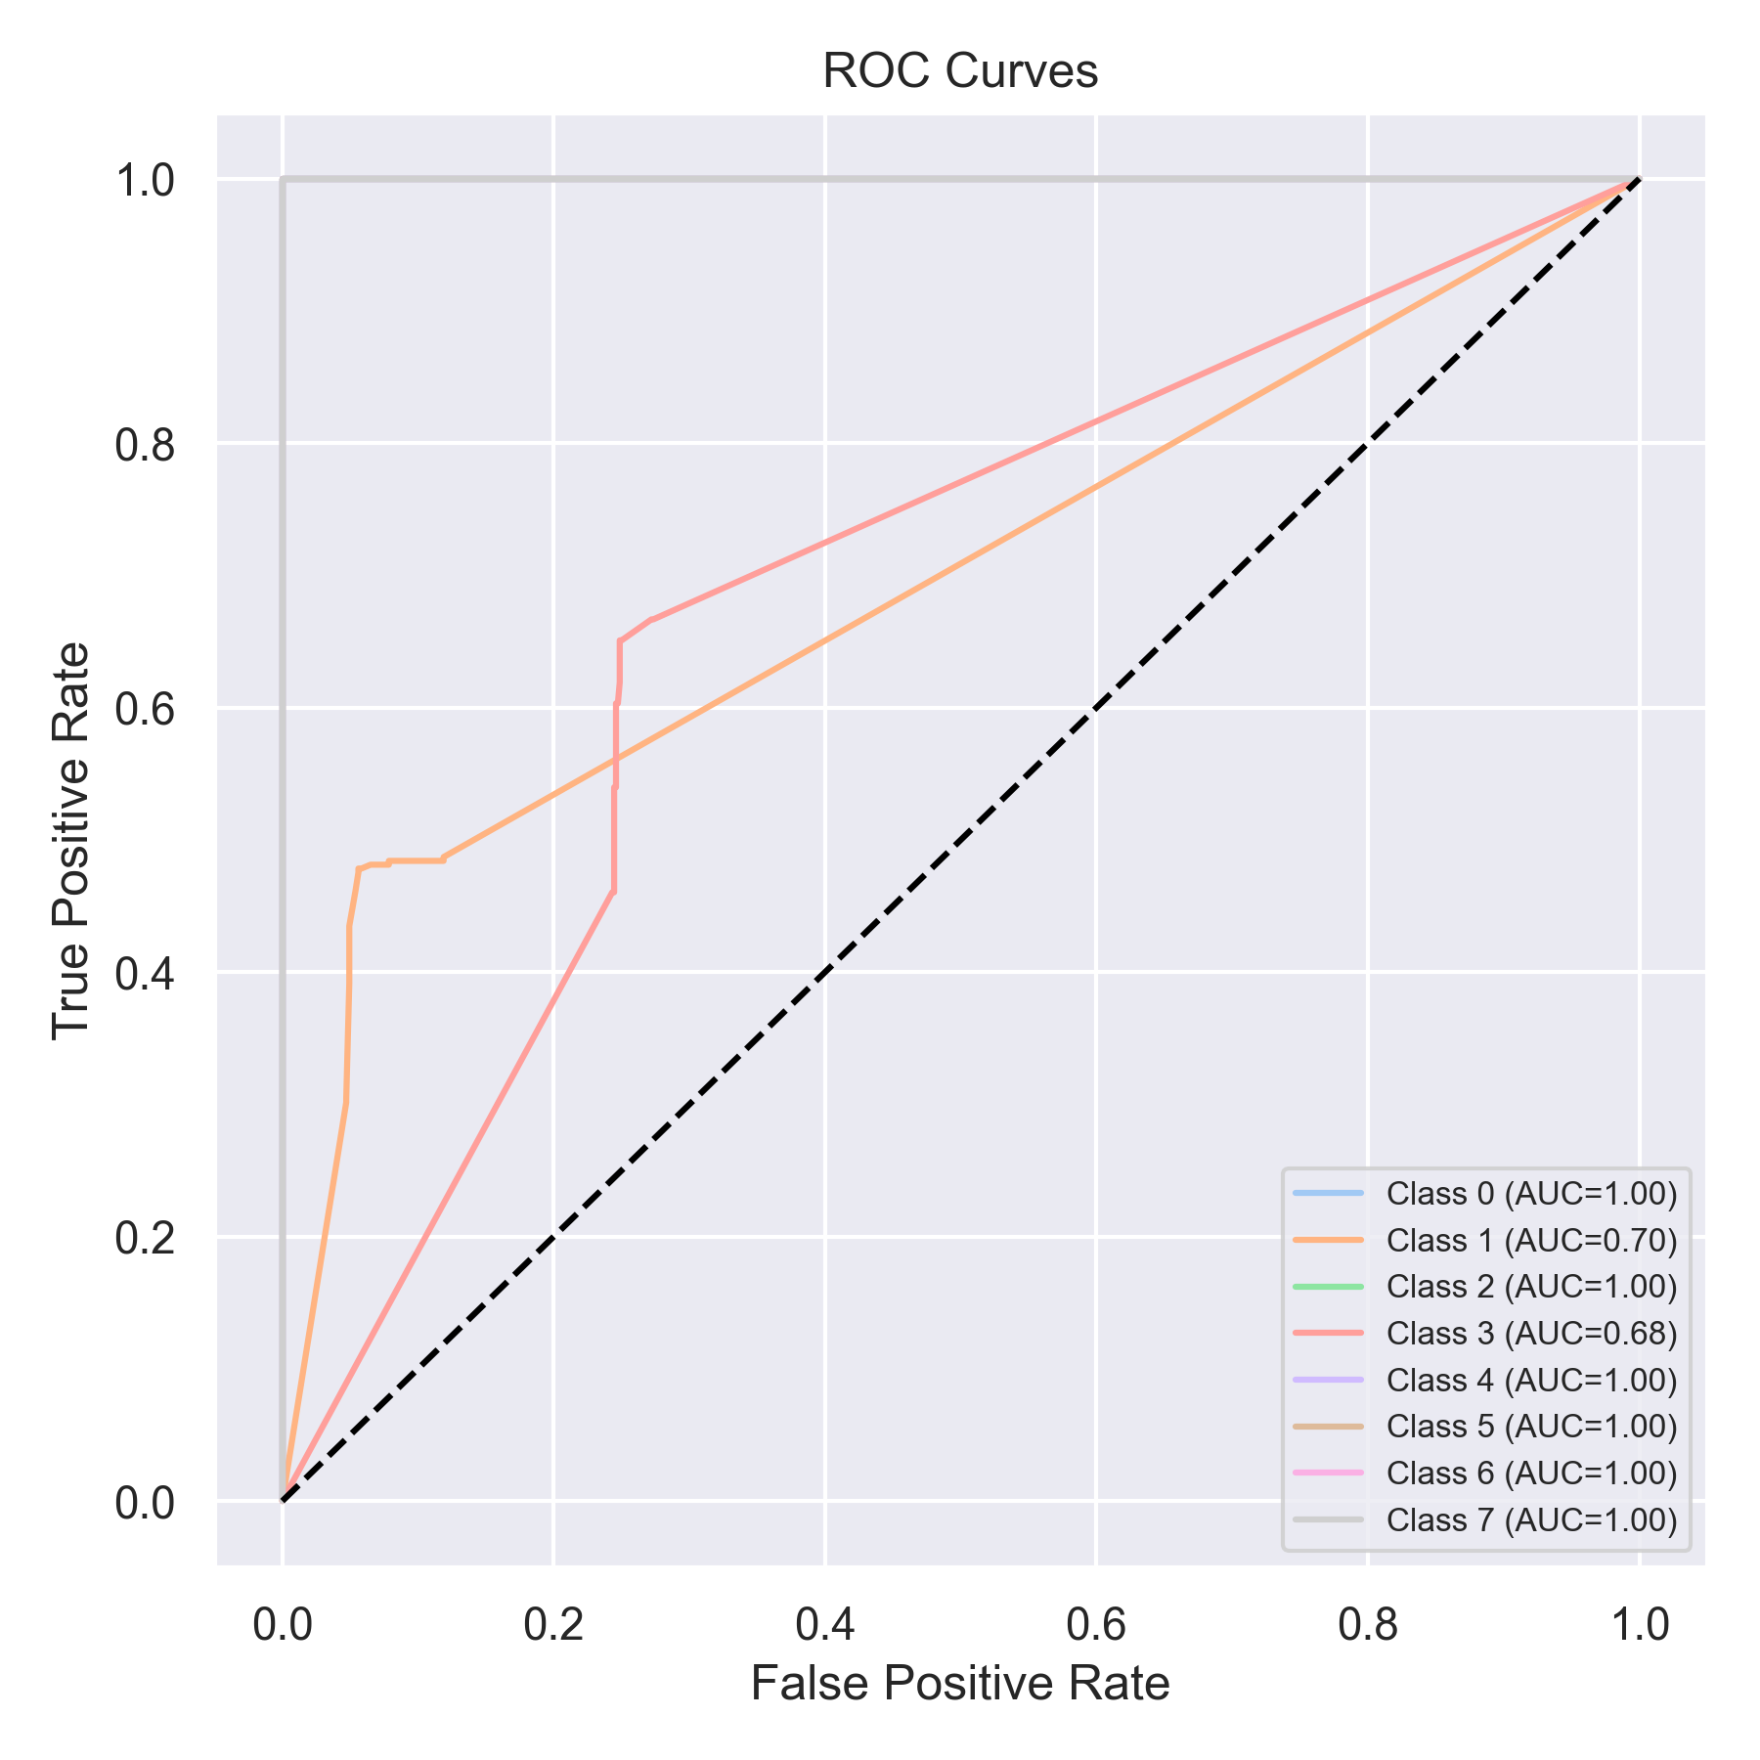

Evaluation: XGBoost
Accuracy: 0.7446270543615676
Precision: 0.8798632051894401
Recall: 0.7446270543615676
F1 Score: 0.7781685755797498
Jaccard Index: 0.6944794337914055
Matthews CorrCoef: 0.7259325942399414
Cohen’s Kappa: 0.6922214560065955
Specificity: 0.96271035578771
AUC: 1.0
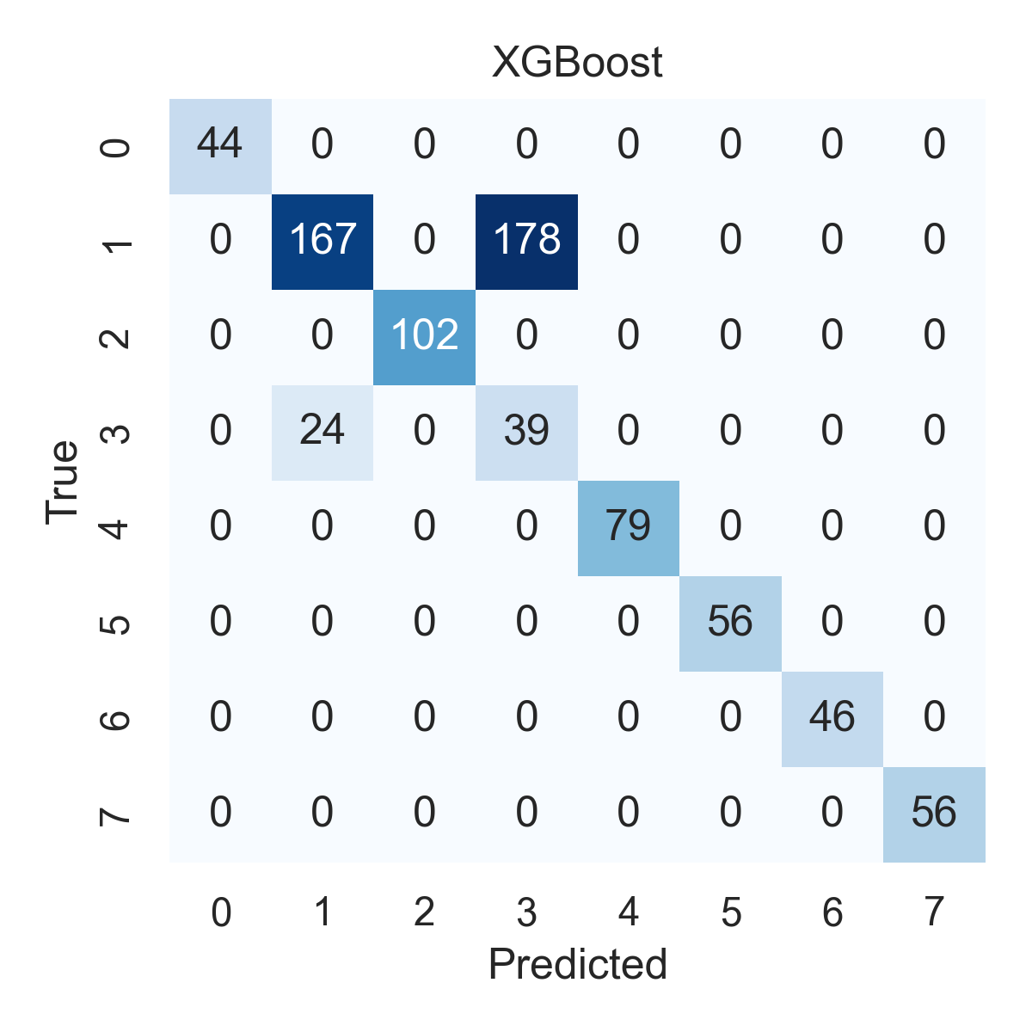

Combined ROC Curves
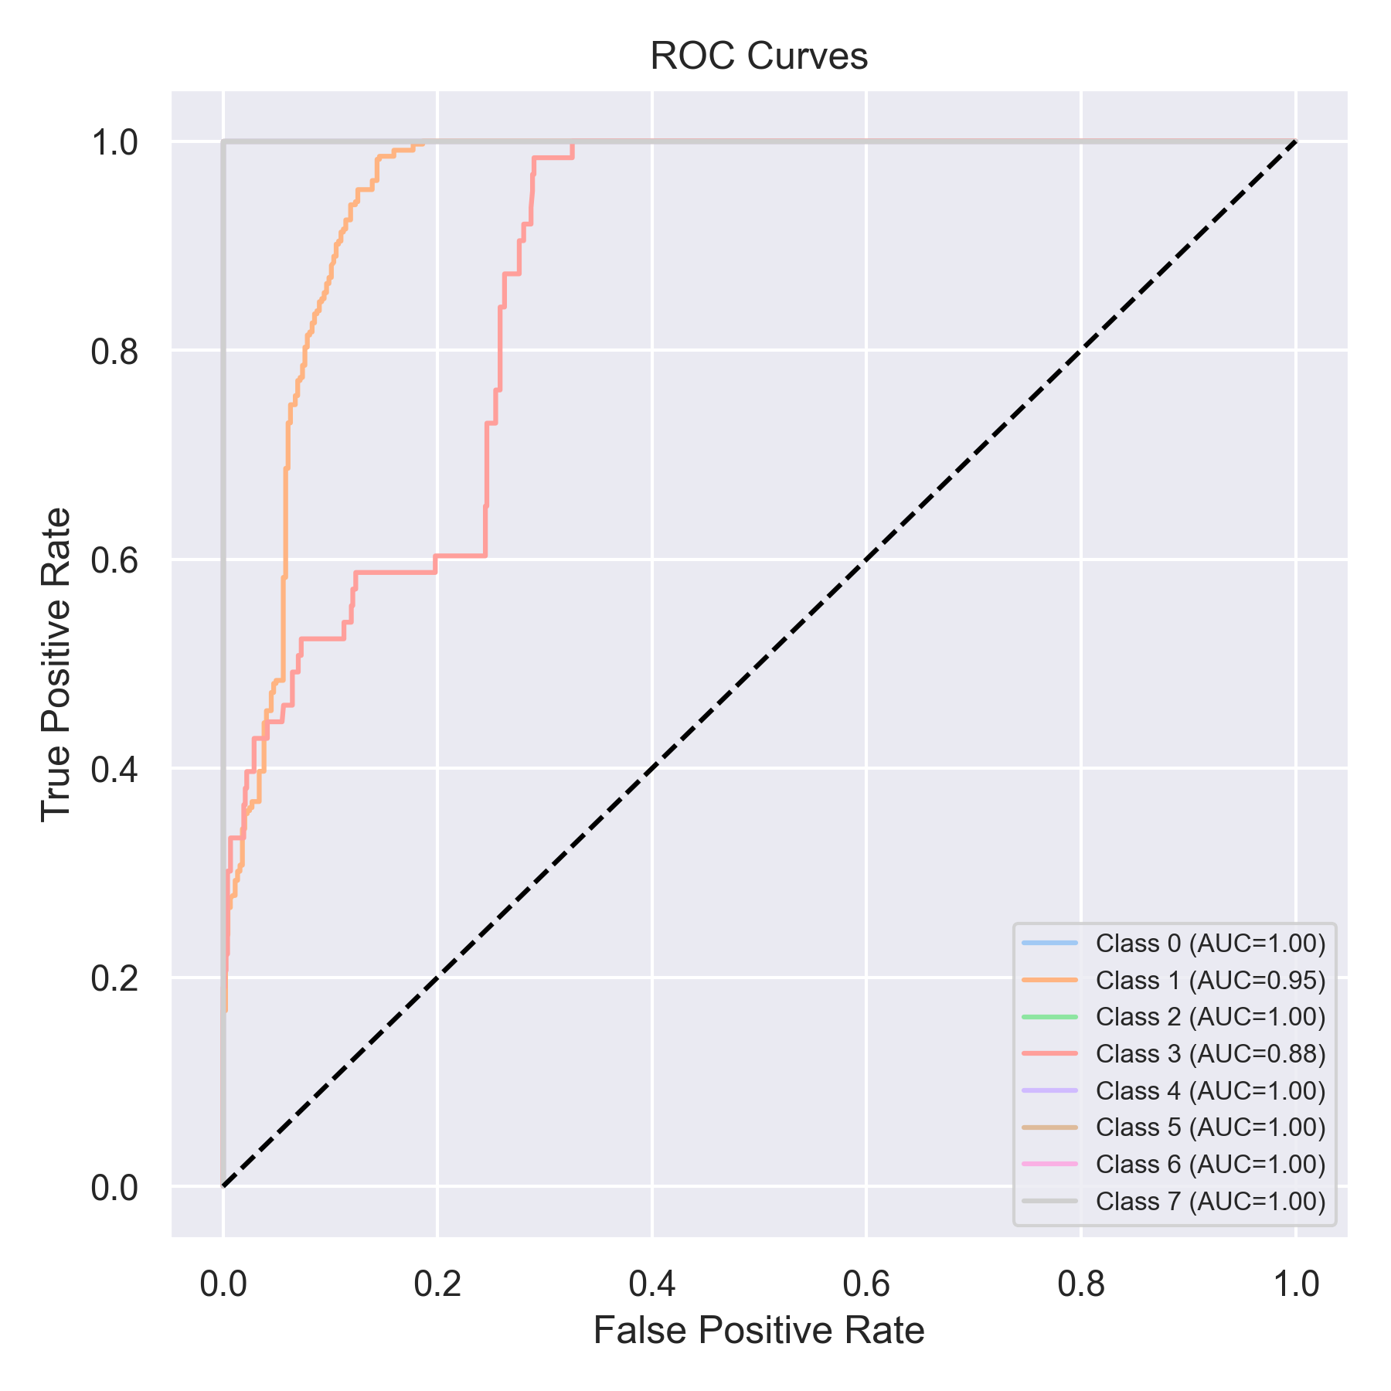

Evaluation: LightGBM
Accuracy: 0.7787610619469026
Precision: 0.890504284309594
Recall: 0.7787610619469026
F1 Score: 0.8092849368226775
Jaccard Index: 0.7277603416340812
Matthews CorrCoef: 0.7547967939222866
Cohen’s Kappa: 0.7296893551209149
Specificity: 0.9674549105602916
AUC: 1.0
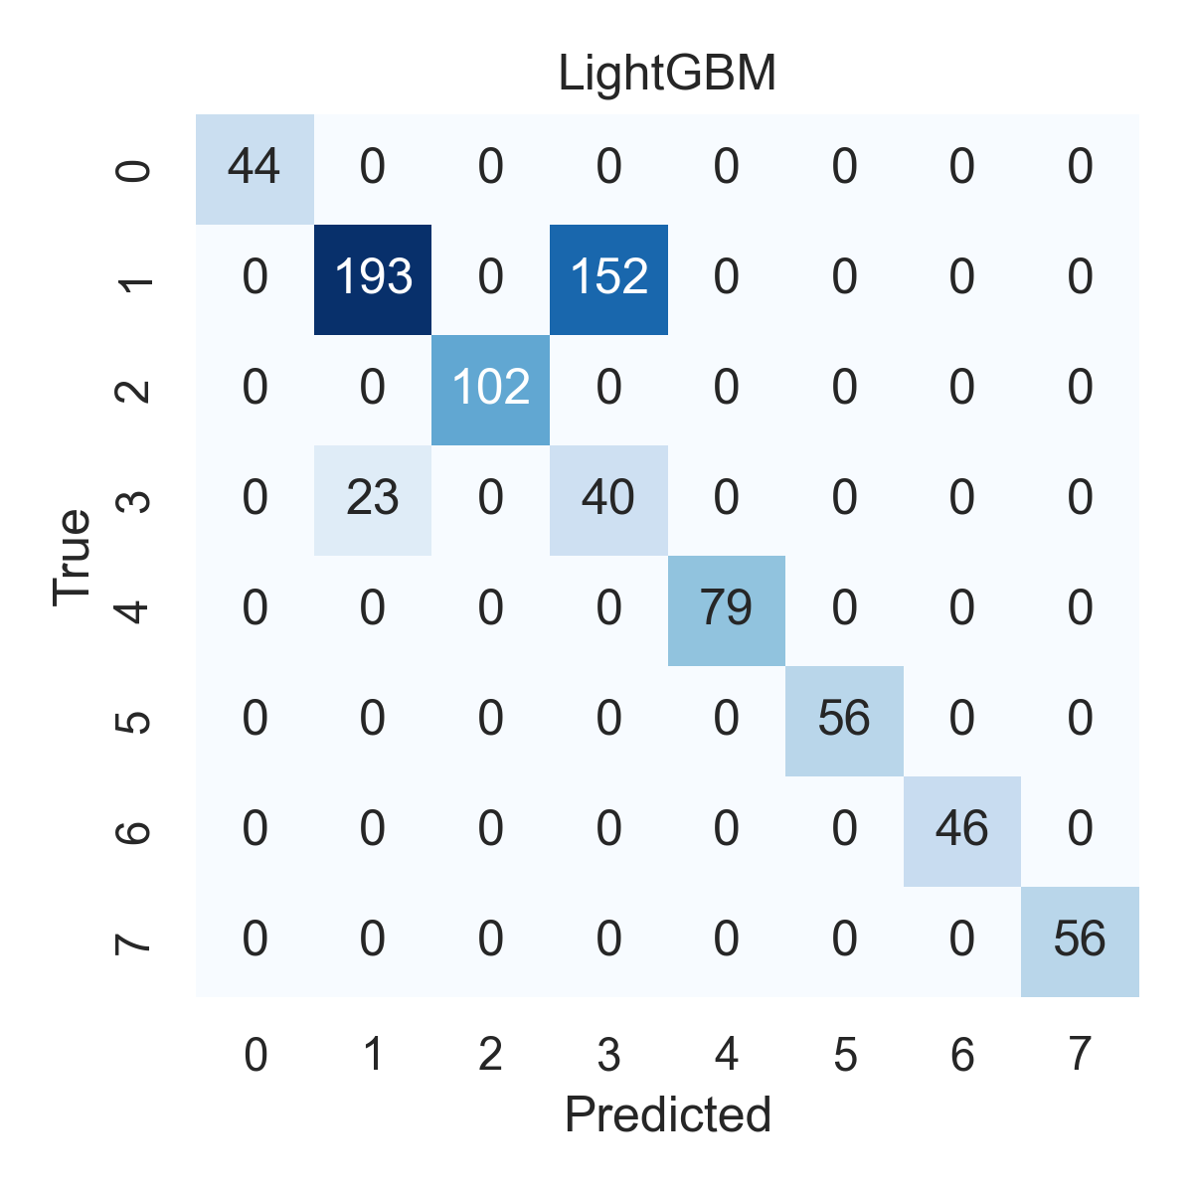

Combined ROC Curves
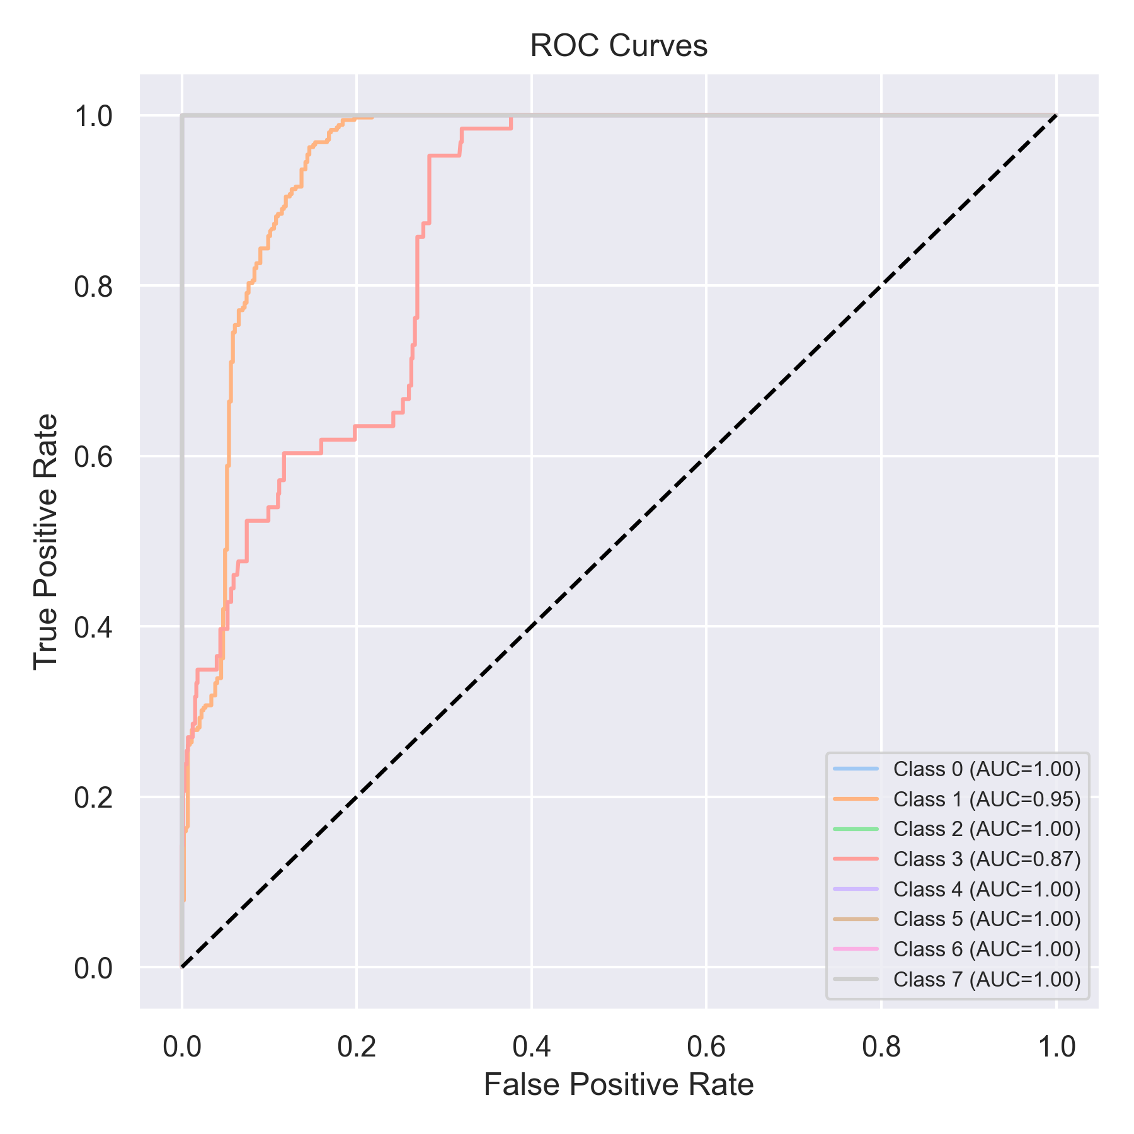

Evaluation: CatBoost
Accuracy: 0.05562579013906448
Precision: 0.0030942285285952427
Recall: 0.05562579013906448
F1 Score: 0.005862358721242723
Jaccard Index: 0.0030942285285952427
Matthews CorrCoef: 0.0
Cohen’s Kappa: 0.0
Specificity: 0.875
AUC: 1.0
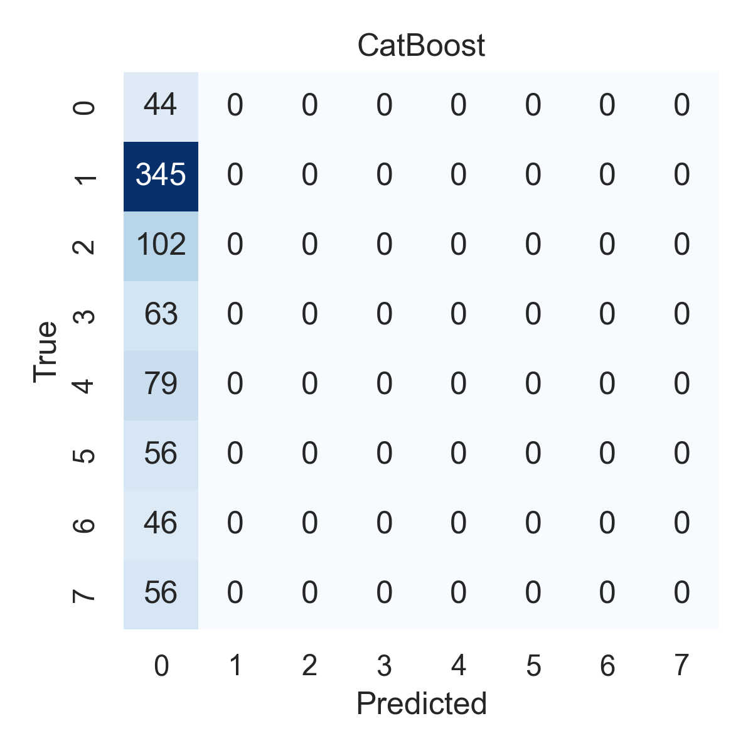

Combined ROC Curves
